
a
Company
Logotype

Cone Beam Computed Tomography- Report



Porur Dental X-rays & CBCT

Patient Name : Miss. Mithra | Date of Report : 13.11.2025
Age/ Gender : 16 years/ Female | Region of Interest : CBCT Full Skull
Referring doctor: Dr. Smilez | Indication : Orthodontic evaluation
Clinical Notes: Nil
PATIENT INFORMATION

CBCT- Full Skull provided
CBCT – IMAGE DETAILS

RADIOGRAPHIC INTERPRETATION

- No of teeth present in the maxillary and mandibular arch: 32; Unerupted teeth: 18, 28
- The maxillary and mandibular alveolar ridge are present with normal trabecular pattern.
- The mandible appears to have a slight midline shift towards the right side, as the midline of the mandibular teeth appears deviated towards the right side when compared with the maxillary teeth midline.
- Protrusion of maxillary anterior teeth and anterior crossbite is evident.
- High arched palate is present.
- The right condylar head appears narrow when compared to the left side.
- Deviated nasal septum towards the right side is evident.

RADIOGRAPHIC IMPRESSION

- Malocclusion
- Nasal septum deviation.

Kindly correlate with clinical findings


IMAGES FOR REFERENCE

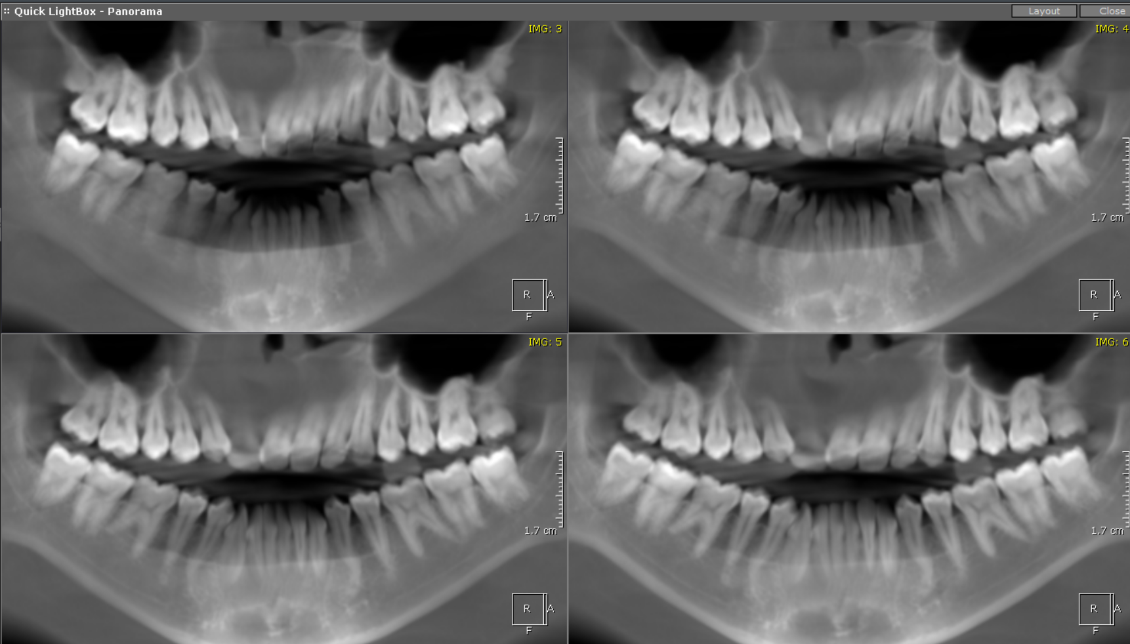
RECONSTRUCTED PANORAMIC VIEW

3-DIMENSIONAL VIEW
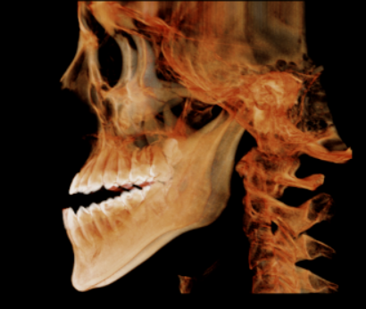

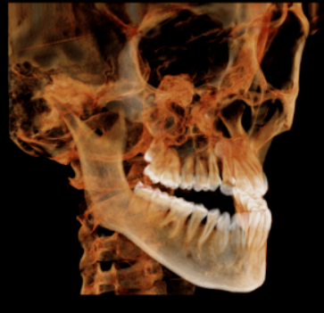
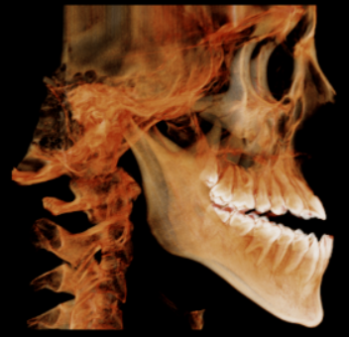
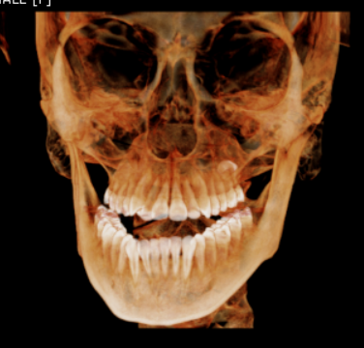
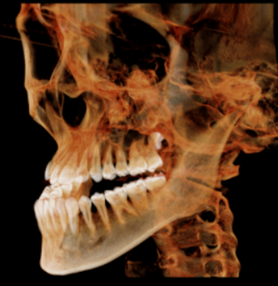
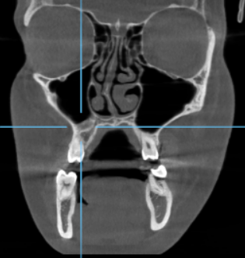
CORONAL VIEW

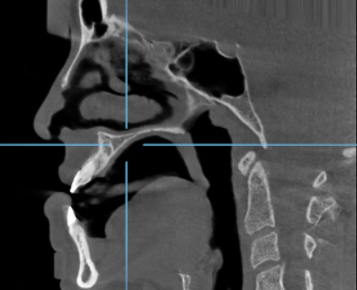

SAGITTAL VIEW

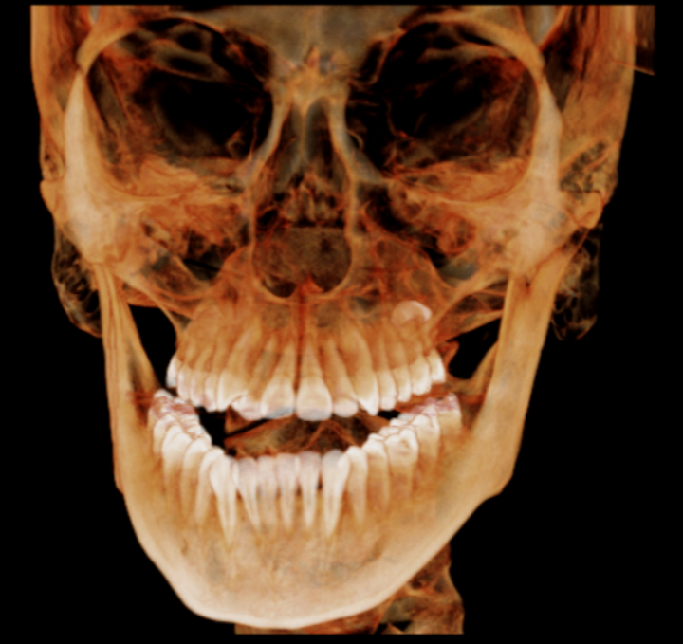

MPR VIEW

*** End of report ****

